WASTE DISPOSAL MANAGEMENT SYSTEM

Narration:

The waste disposal management system is a complex and essential process that operates seamlessly across multiple locations, prioritizing the efficient and responsible handling of waste. It all starts at the source, where households produce a variety of waste, including general garbage, leftovers, and recyclables. Apartment complexes often provide designated collection points for residents to conveniently deposit their waste.

Sanitation workers, play a vital role as they collect the waste from homes and transport it to a central collection point using specialized trucks. At this central hub, waste is sorted independently into different categories. Recyclable materials, such as paper, plastic, glass, and metal, are separated for recycling. Meanwhile, organic waste, which includes food scraps is set aside for composting. Non-organic waste is categorized for further processing.

The sorted recyclable materials are then sent to recycling facilities for processing, where they undergo various methods to be transformed into usable materials. The organic waste goes through a composting process, ultimately resulting in nutrient-rich compost that can enrich soil and support sustainable agriculture. Non-organic waste is subjected to specialized methods.

Throughout this intricate process, waste management authorities play a pivotal role in ensuring compliance with environmental regulations. They monitor waste quantities, emissions, and responsible waste disposal practices to safeguard the environment and the well-being of the community.

There are 4 types of drawing:

1. Use case:

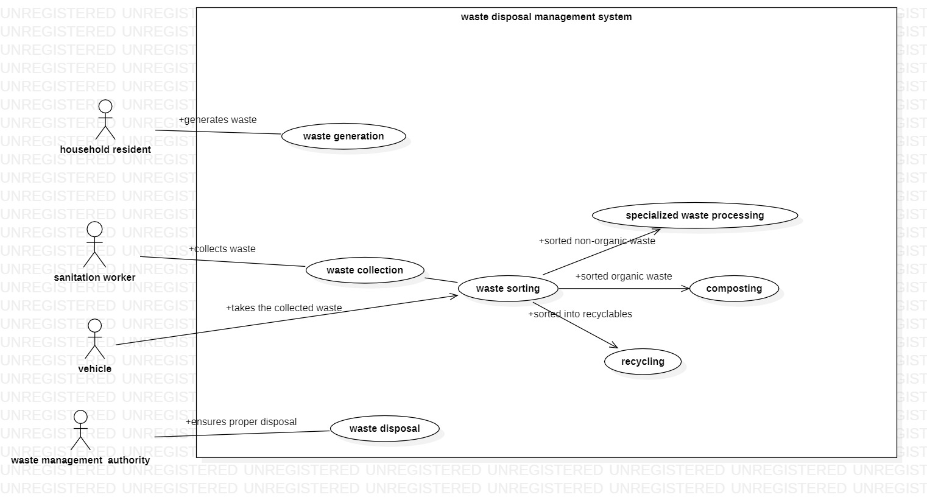

the use case for the following use case diagrams is:

Scenario 1: Household Resident Disposes of Waste

Primary Actor: Household Resident

Supporting Actors: Sanitation Worker, Waste Management Authority

Preconditions:

The household resident has generated waste.

The household resident has sorted the waste into organic and non-organic waste.

The household resident has placed the waste in the appropriate waste bins.

Postconditions:

The waste has been collected from the household resident's premises.

The waste has been transported to the appropriate waste processing facility.

The waste has been disposed of in a safe and environmentally friendly manner.

Basic Flow:

The household resident places the sorted waste in the appropriate waste bins.

The sanitation worker collects the waste bins from the household resident's premises.

The sanitation worker transports the waste bins to the appropriate waste processing facility.

The waste is processed at the waste processing facility.

The waste is disposed of in a safe and environmentally friendly manner.

Alternate Flows:

If the household resident has not sorted the waste, the sanitation worker may sort the waste on behalf of the household resident.

If the household resident has hazardous waste, the sanitation worker may collect the hazardous waste separately and dispose of it in a special manner.

If the waste processing facility is closed, the sanitation worker may store the waste bins at a temporary storage location until the waste processing facility reopens.

Scenario 2: Company Recycles Waste

Primary Actor: Company

Supporting Actors: Waste Management Authority, Recycling Company

Preconditions:

The company has generated recyclable waste.

The company has sorted the recyclable waste into different types of materials, such as paper, plastic, metal, and glass.

The company has stored the sorted recyclable waste in a designated area.

Postconditions:

The recyclable waste has been collected from the company's premises.

The recyclable waste has been transported to the recycling company.

The recyclable waste has been recycled into new products.

Basic Flow:

The company sorts the recyclable waste into different types of materials.

The company stores the sorted recyclable waste in a designated area.

The company contacts the waste management authority to schedule a pickup for the recyclable waste.

The waste management authority collects the recyclable waste from the company's premises.

The waste management authority transports the recyclable waste to the recycling company.

The recycling company recycles the recyclable waste into new products.

Alternate Flows:

If the company has a large volume of recyclable waste, the waste management authority may provide the company with a dumpster for the recyclable waste.

If the company generates hazardous waste, the waste management authority may collect the hazardous waste separately and dispose of it in a special manner.

If the recycling company is closed, the waste management authority may store the recyclable waste at a temporary storage location until the recycling company reopens.

2.Time Sequence:  
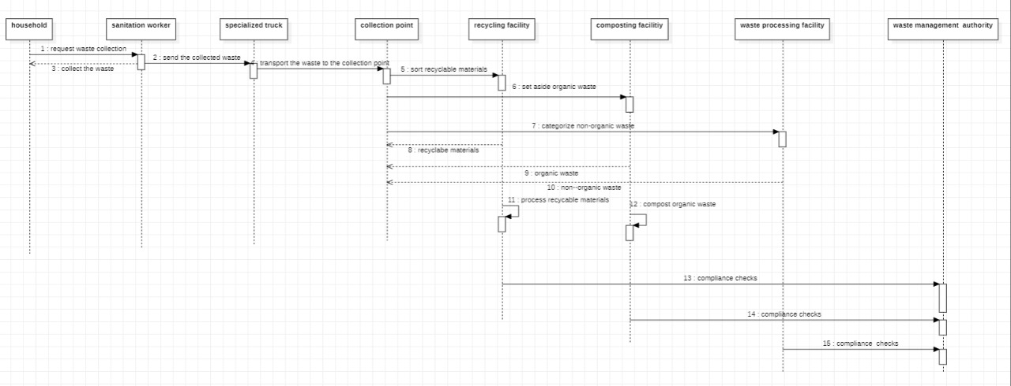

3.Class diagram:

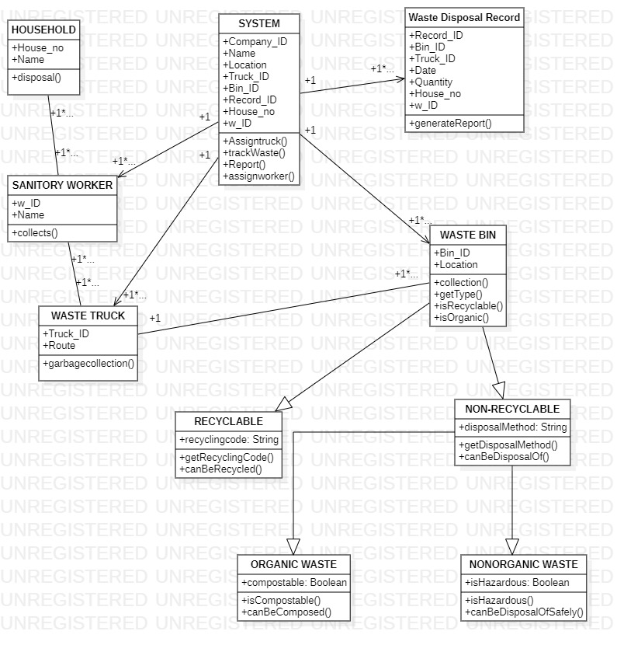

4.Activity diagram:  
